**INFSCI 2725: Data Analytics**

**Assignment 3: Validation and Testing**

**Team members**: Zhenyu Peng

Tong Wei

In this assignment, we utilize GeNIe to deal with all these tasks.

First of all, we import three models and load the data file:



# 1. Overall classification accuracy

Use leave-one-out (as required) validation method to test the model:

 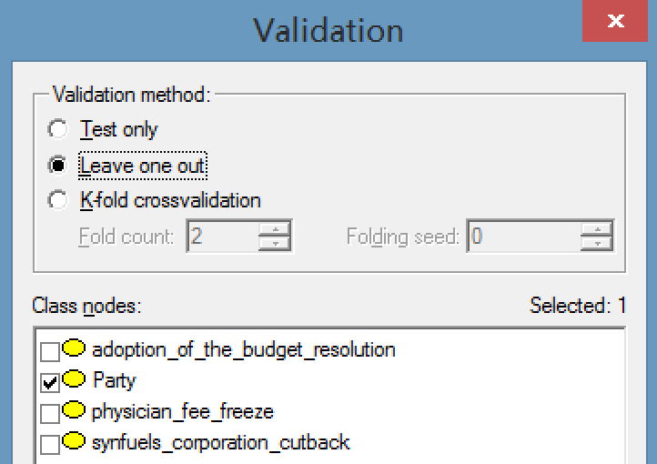

## 1.1 Manually-constructed model:

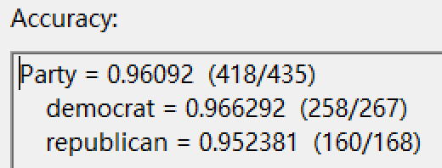

## 1.2 Naive Bayes algorithm:

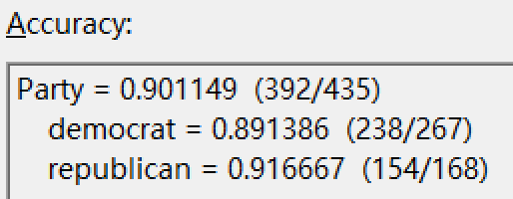

## 1.3 PC algorithm:

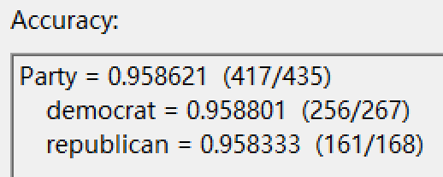

# 2. Sensitivity and specificity for each of the two parties

## 2.1 Manually-constructed model:

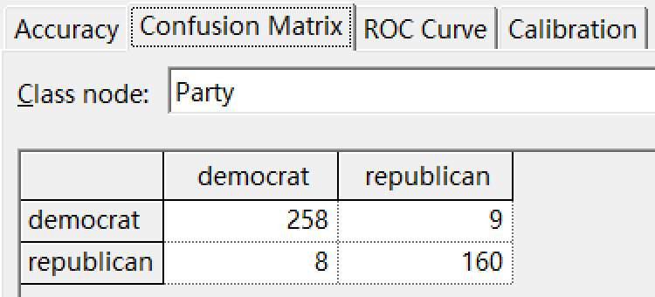

The sensitivity of democrat: 258 / (258+8) = 0.969925

The sensitivity of republican: 160 / (160+9) = 0.946746

The specificity of democrat: 160 / (160+9) = 0.946746

The specificity of republican: 258 / (258+8) = 0.969925

## 2.2 Naive Bayes algorithm:

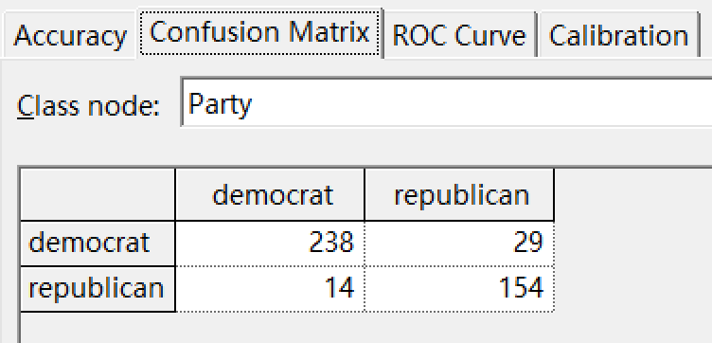

The sensitivity of democrat: 238 / (238+14) = 0.944444

The sensitivity of republican: 154 / (154+29) = 0.841530

The specificity of democrat: 154 / (154+29) = 0.841530

The specificity of republican: 238 / (238+14) = 0.944444

## 2.3 PC algorithm:

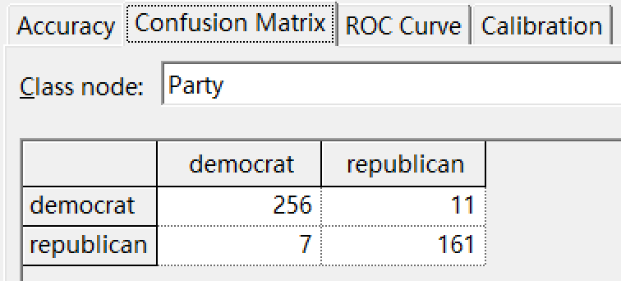

The sensitivity of democrat: 256 / (256+7) = 0.973384

The sensitivity of republican: 161 / (161+11) = 0.936047

The specificity of democrat: 161 / (161+11) = 0.936047

The specificity of republican: 256 / (256+7) = 0.973384

# 3. Positive and negative predictive value for each of the two parties

## 3.1 Manually-constructed model:

The positive value of democrat: 9 / (9+258) = 0.033708

The negative value of democrat: 160 / (160+8) = 0.952381

The positive value of republican: 160 / (160+8) = 0.952381

The negative value of republican: 9 / (9+258) = 0.033708

## 3.2 Naive Bayes algorithm:

The positive value of democrat: 29 / (238+29) = 0.108614

The negative value of democrat: 154 / (154+14) = 0.916667

The positive value of republican: 154 / (154+14) = 0.916667

The negative value of republican: 29 / (238+29) = 0.108614

## 3.3 PC algorithm:

The positive value of democrat: 11 / (256+11) = 0.041199

The negative value of democrat: 161 / (161+7) = 0.958333

The positive value of republican: 161 / (161+7) = 0.958333

The negative value of republican: 11 / (256+11) = 0. 04120

# 4. Calibration curve for a selected bin count or window size

## 4.1 Manually-constructed model:

Bin count 8 and 16:

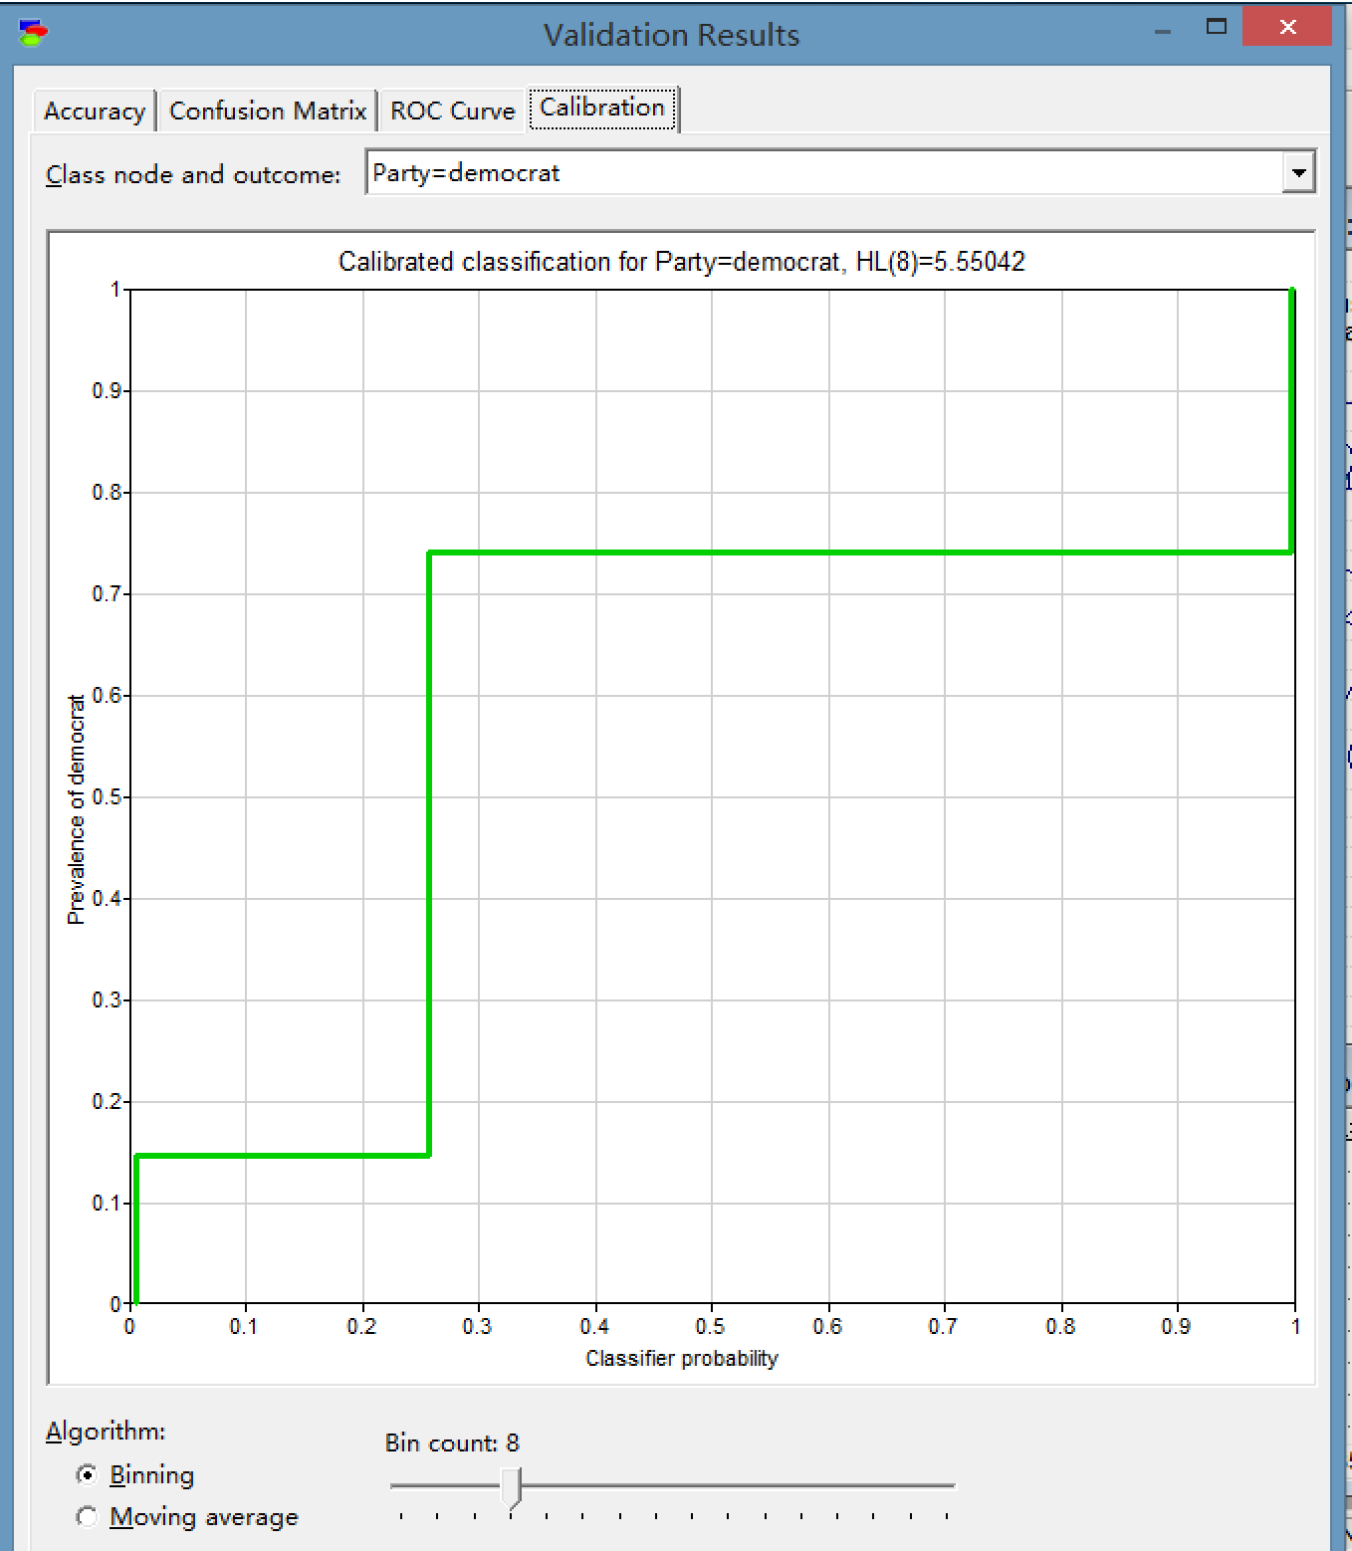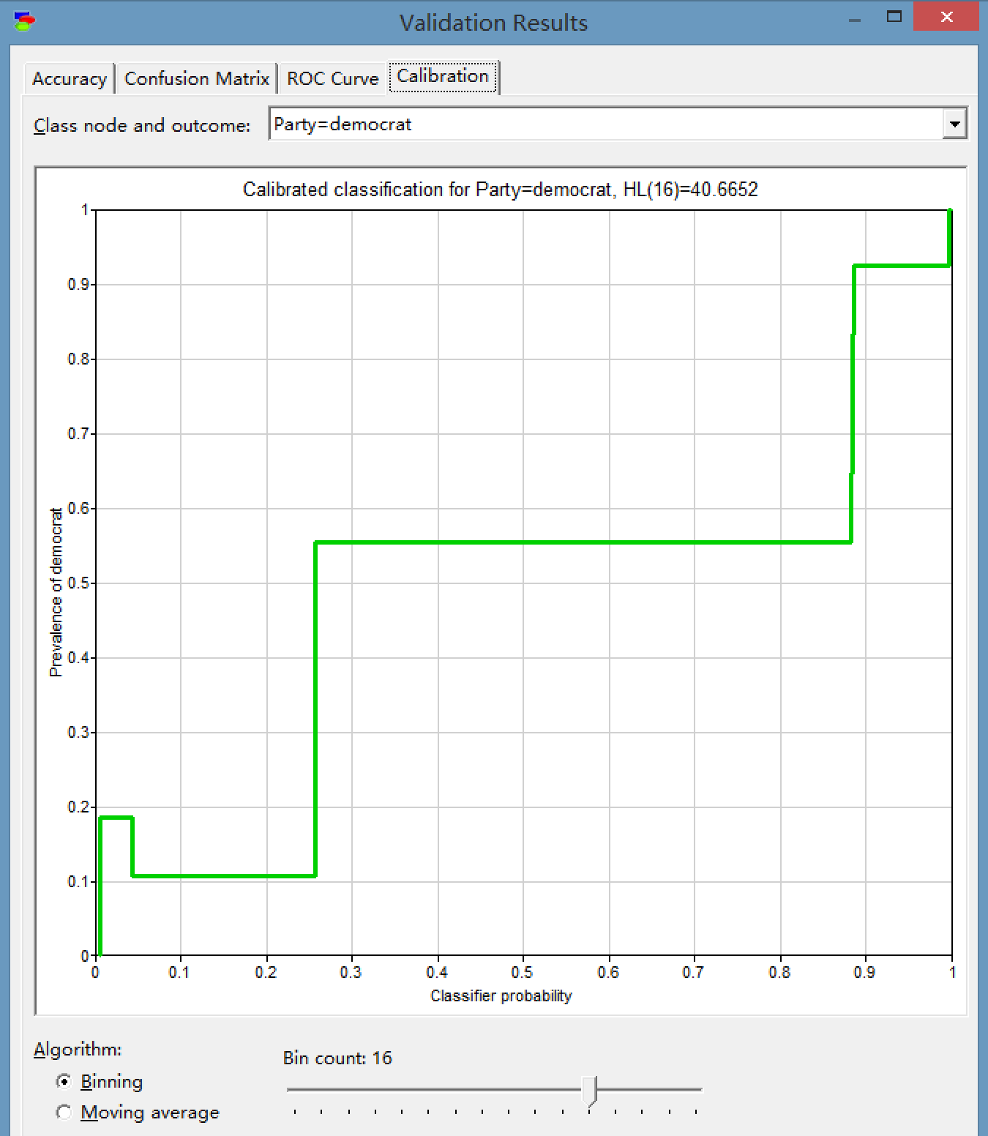

Window size 3 and 13:

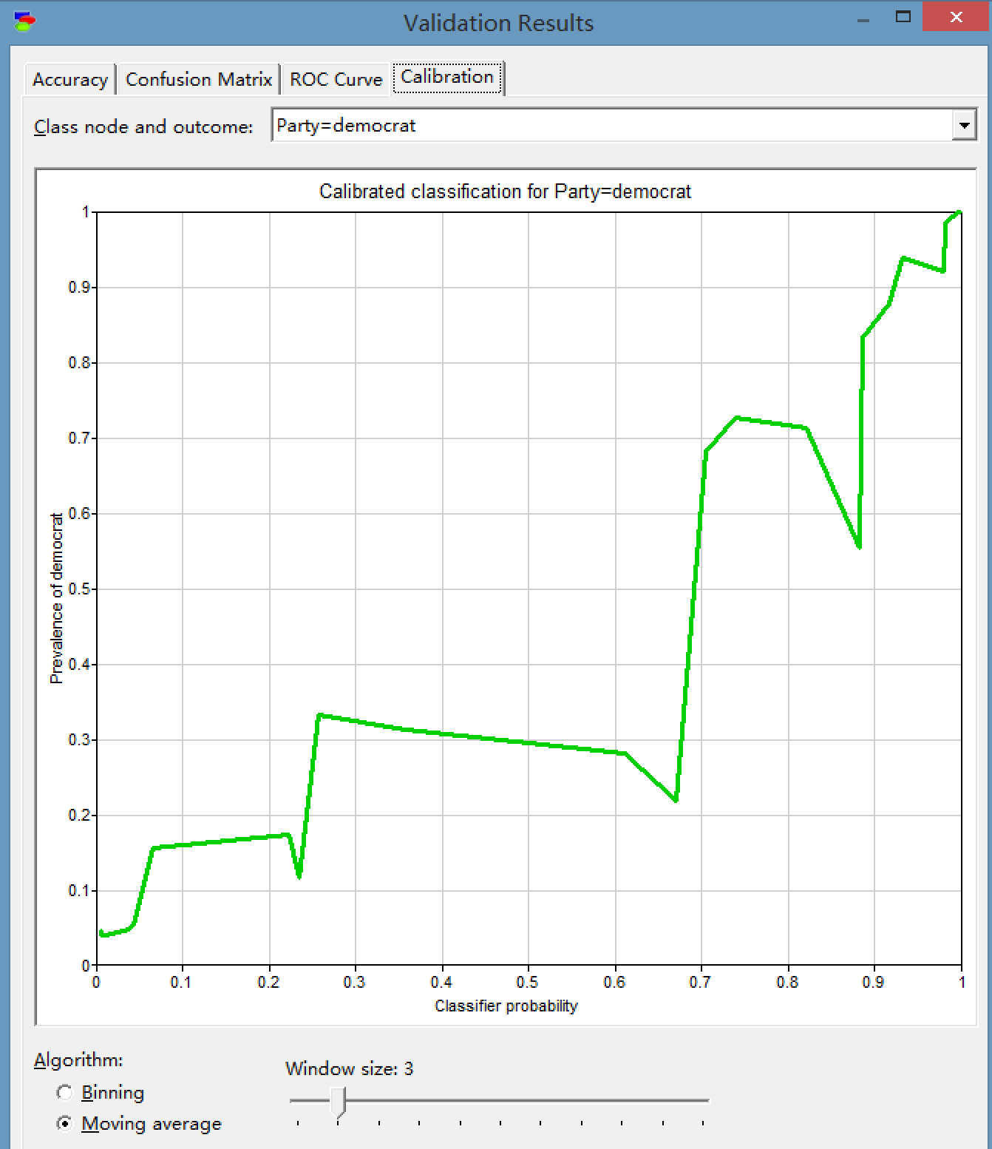 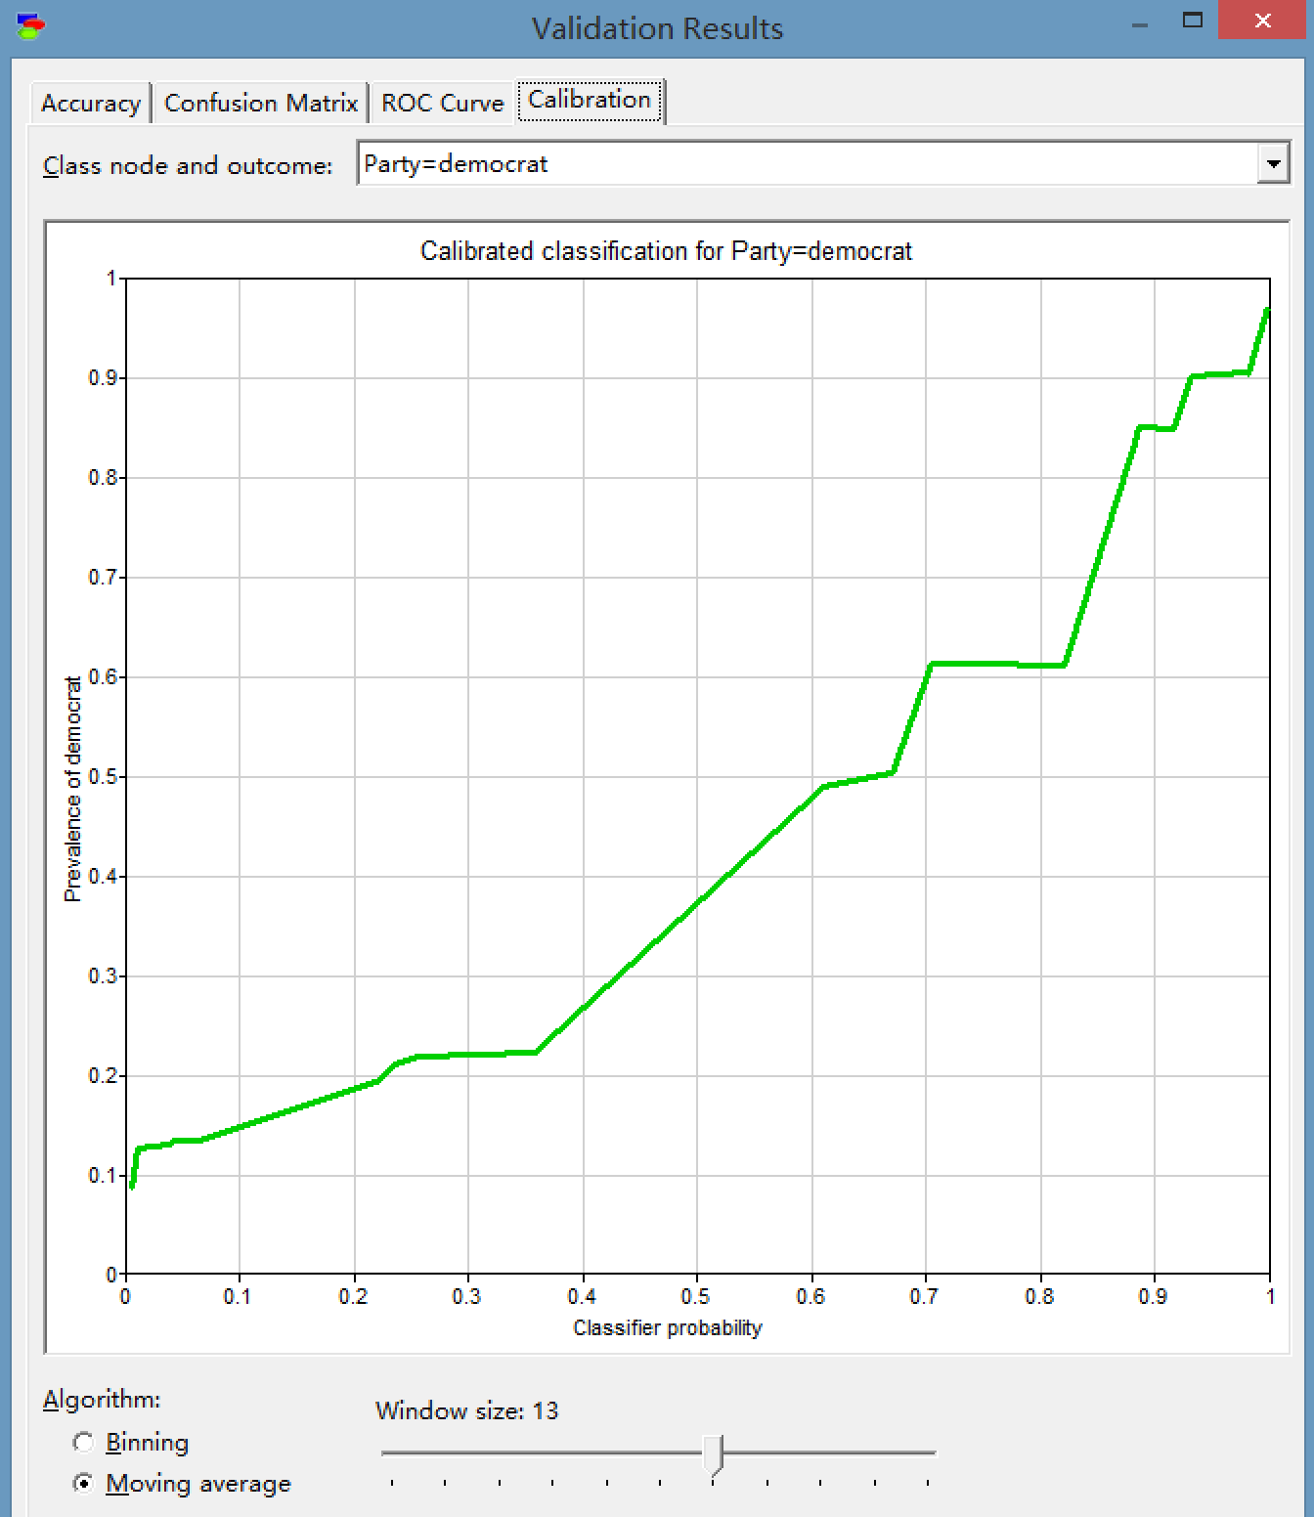

## 4.2 Naive Bayes algorithm:

Bin count 8 and 16:

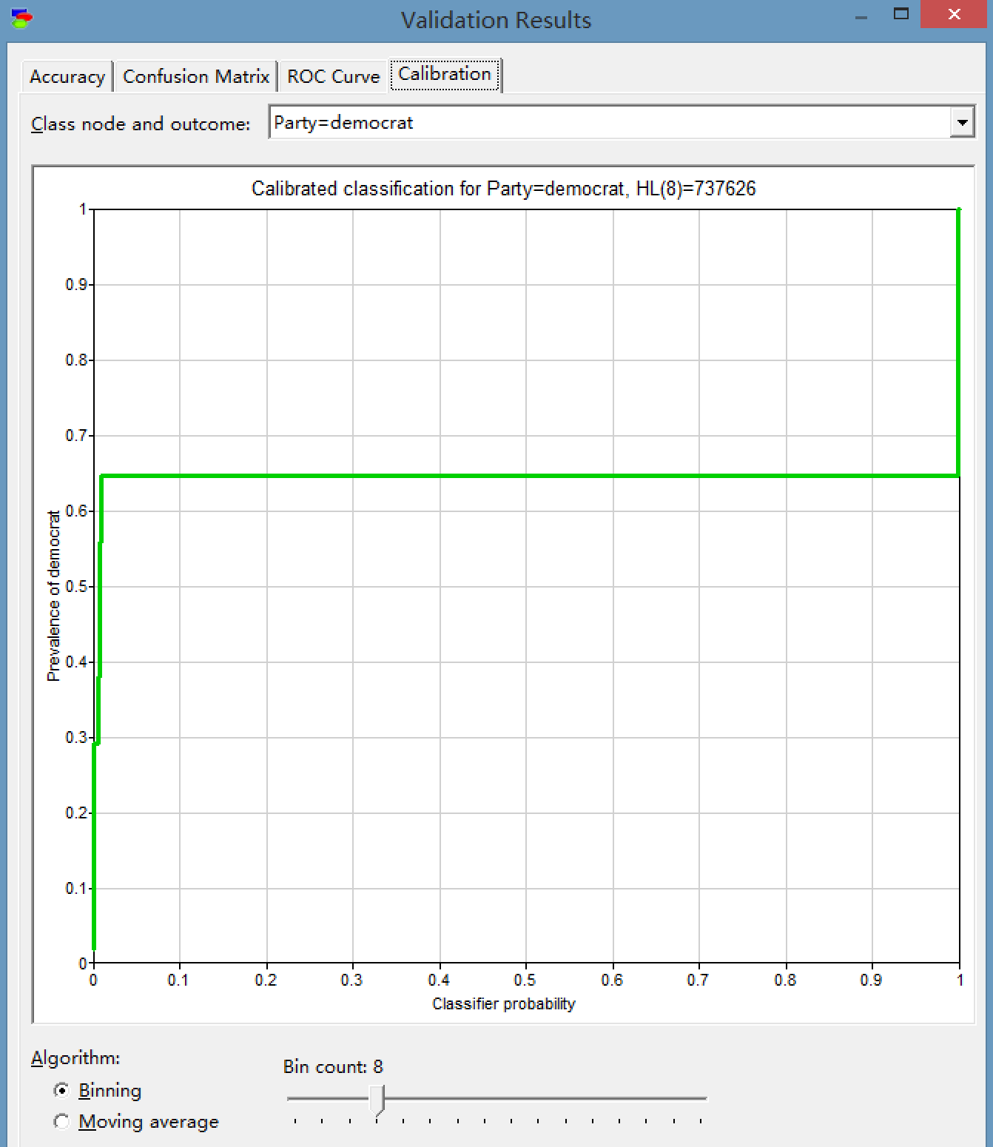 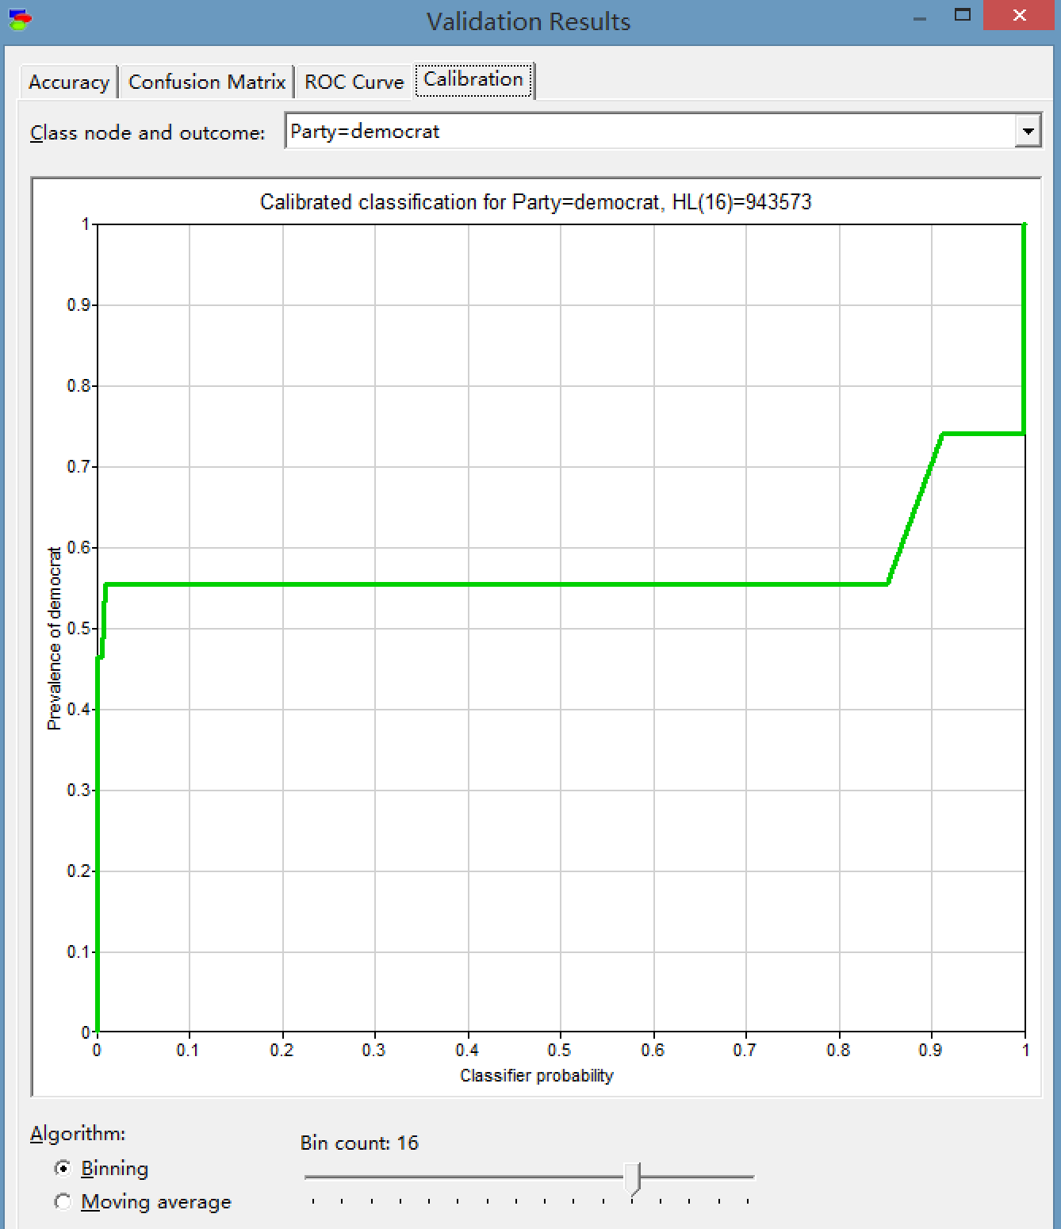

Window size 3 and 13:

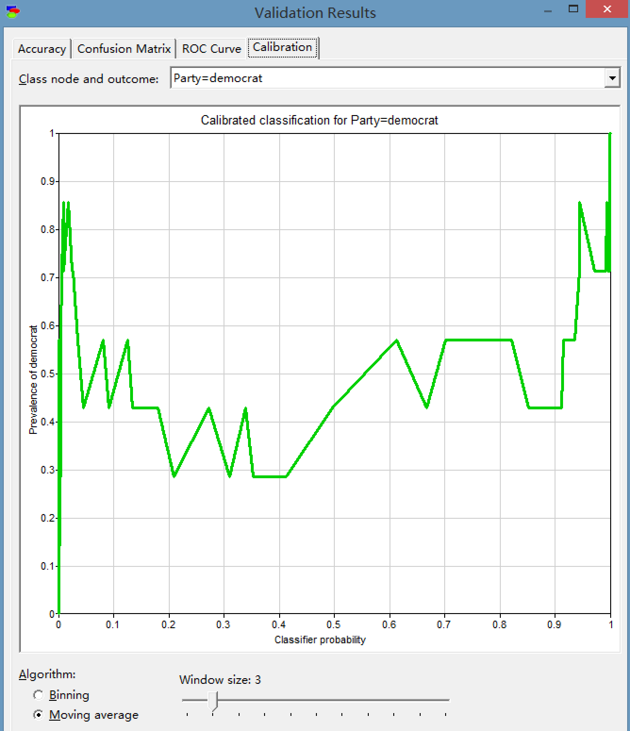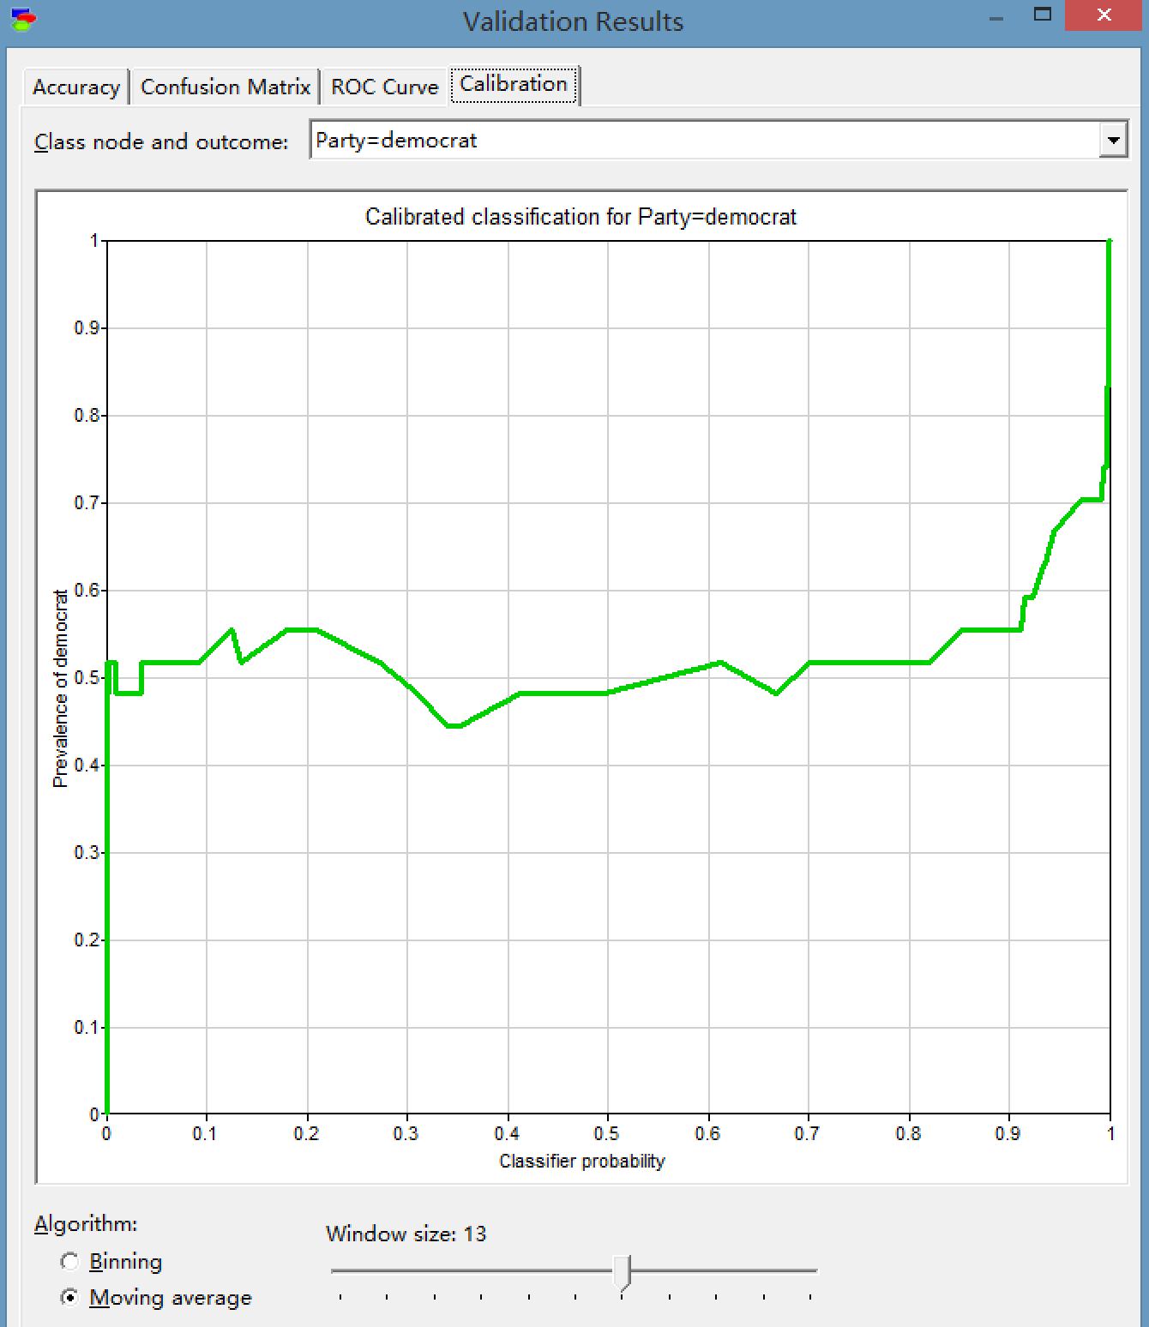

## 4.3 PC algorithm:

Bin count 8 and 16:

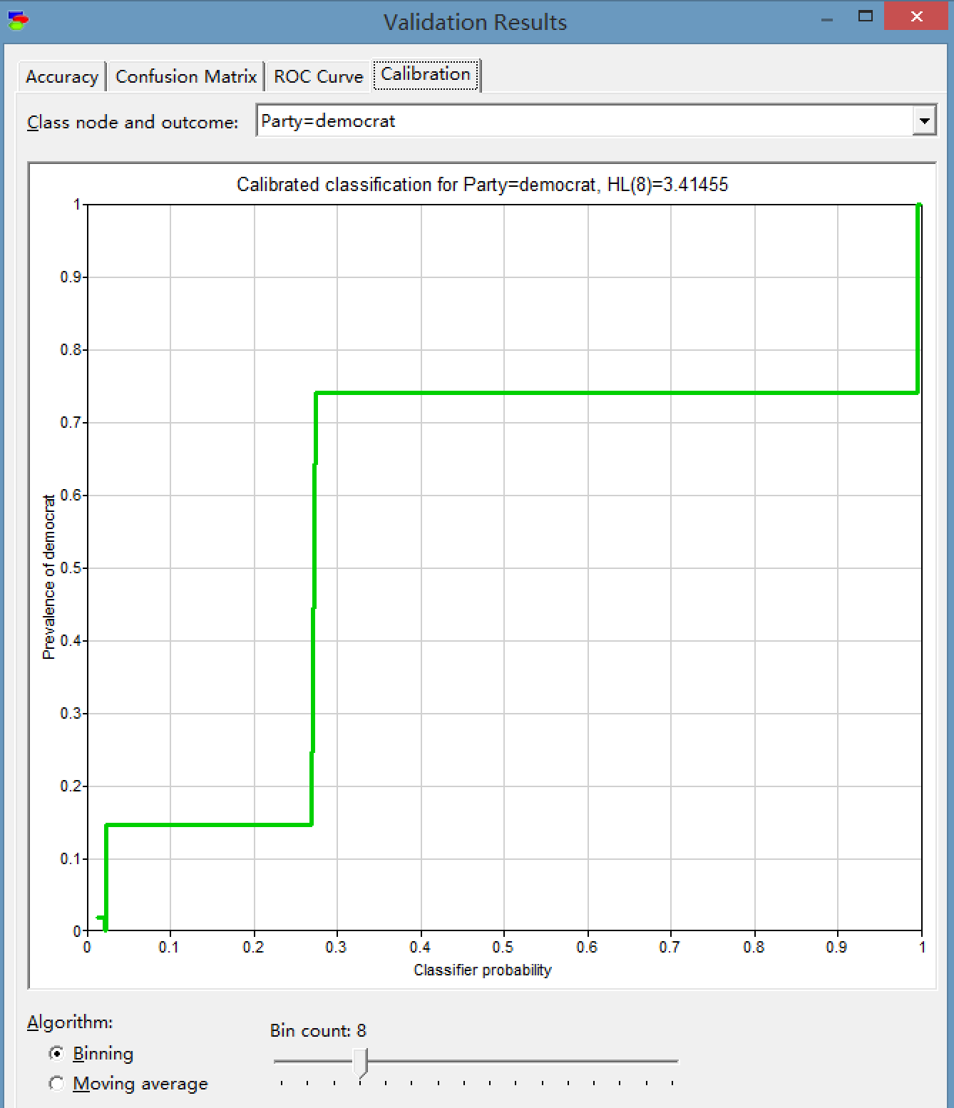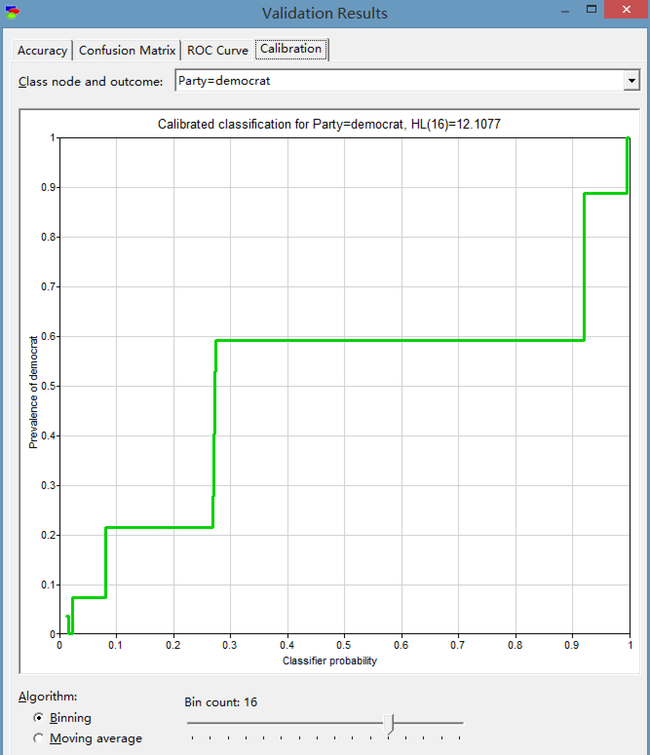

Window size 3 and 13:

